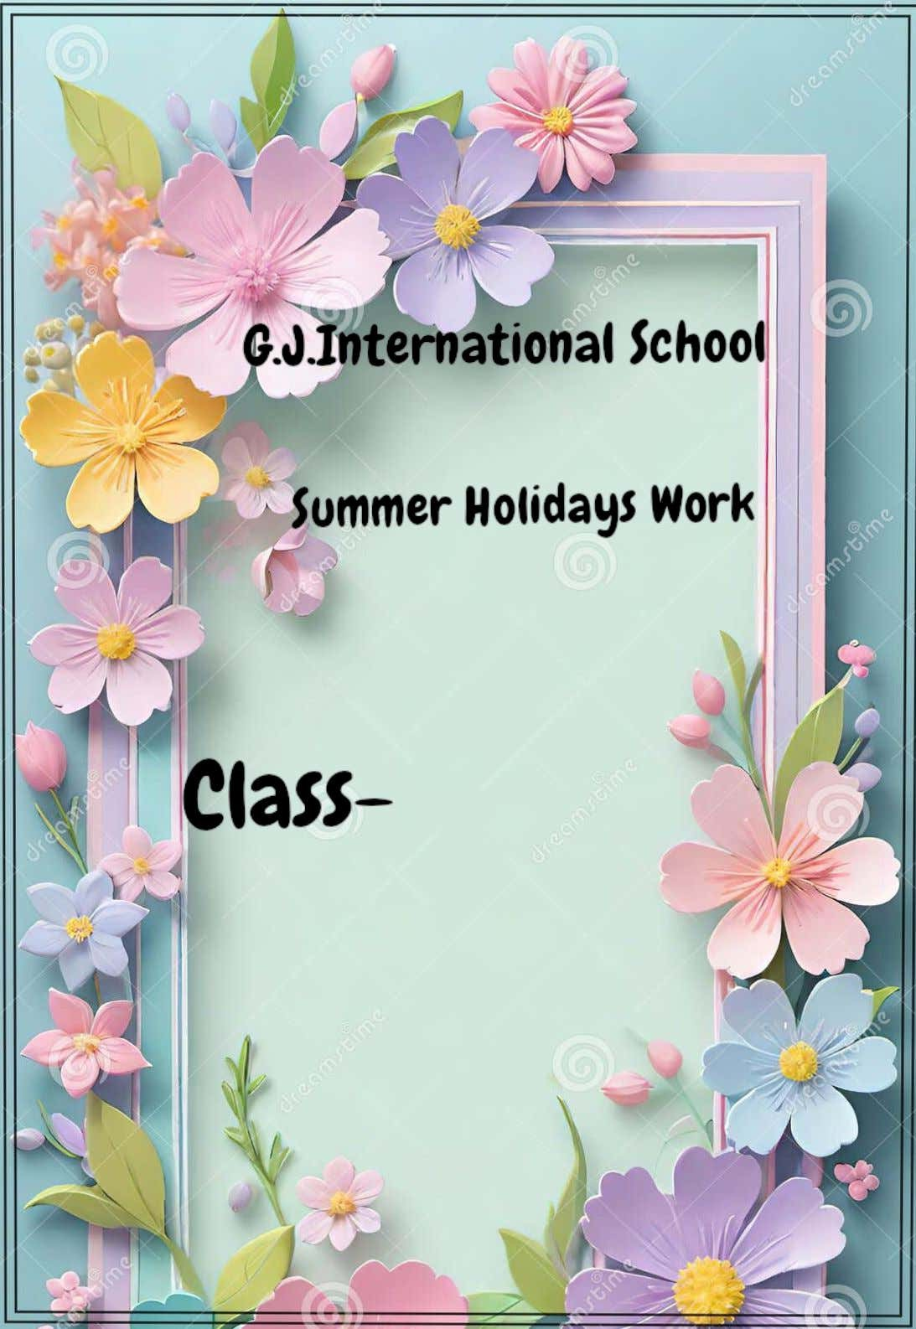

5th

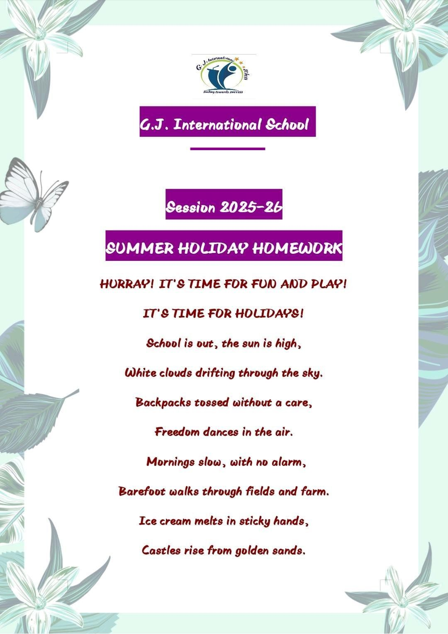
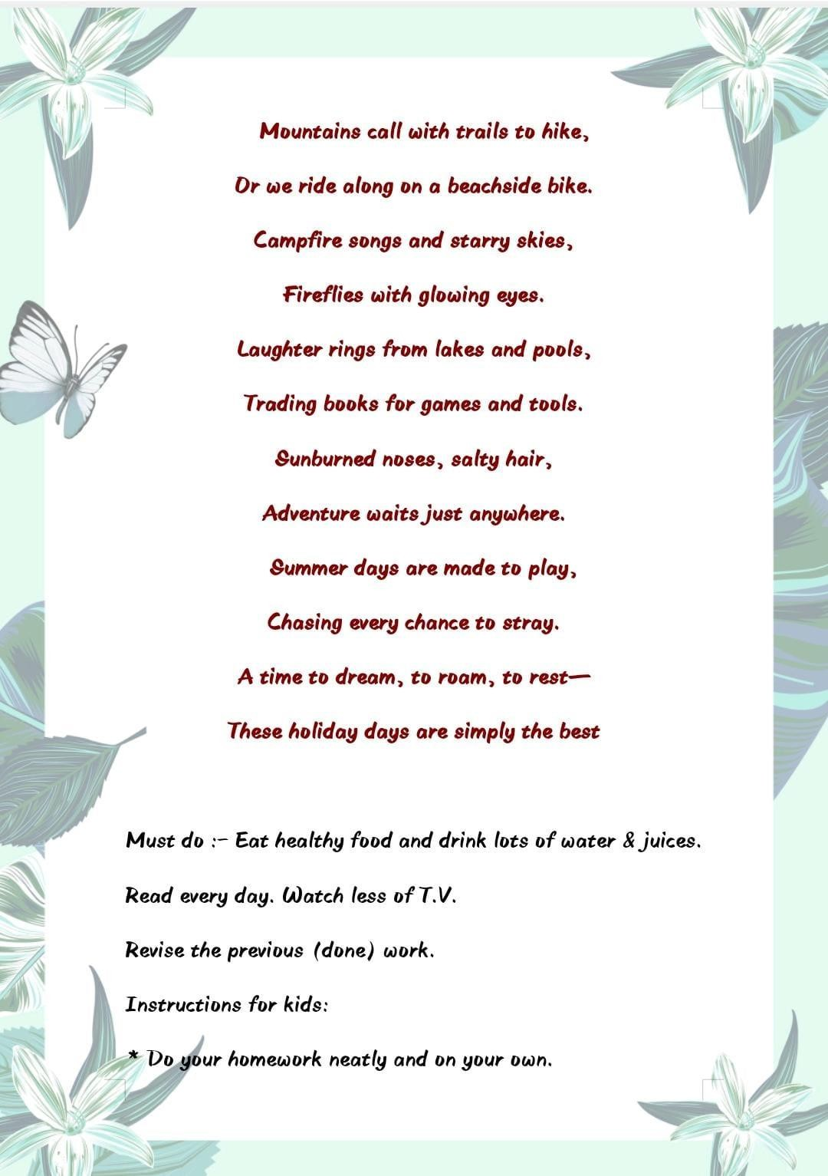
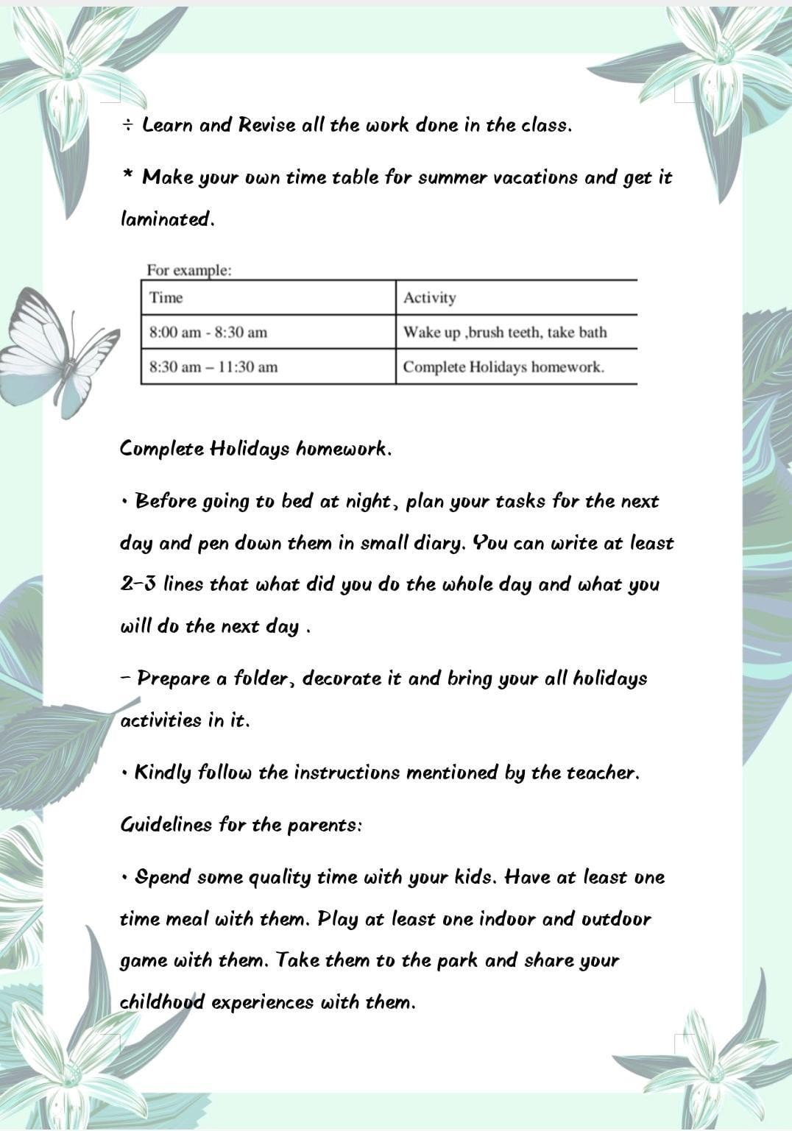
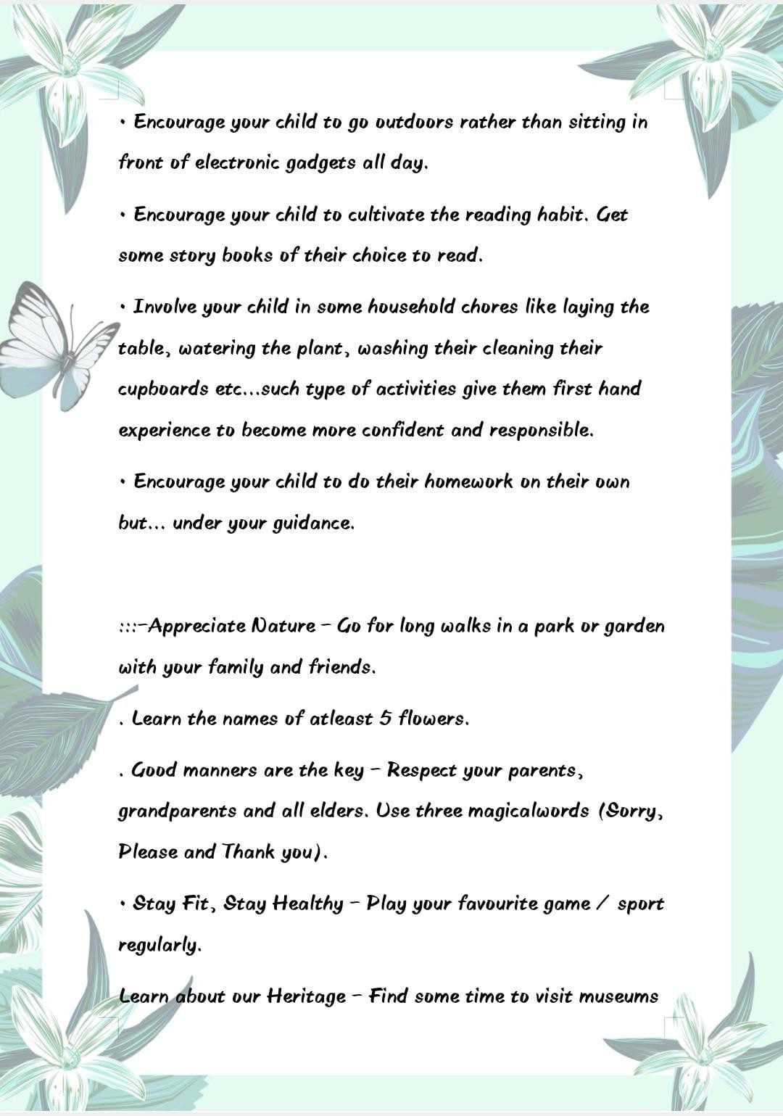
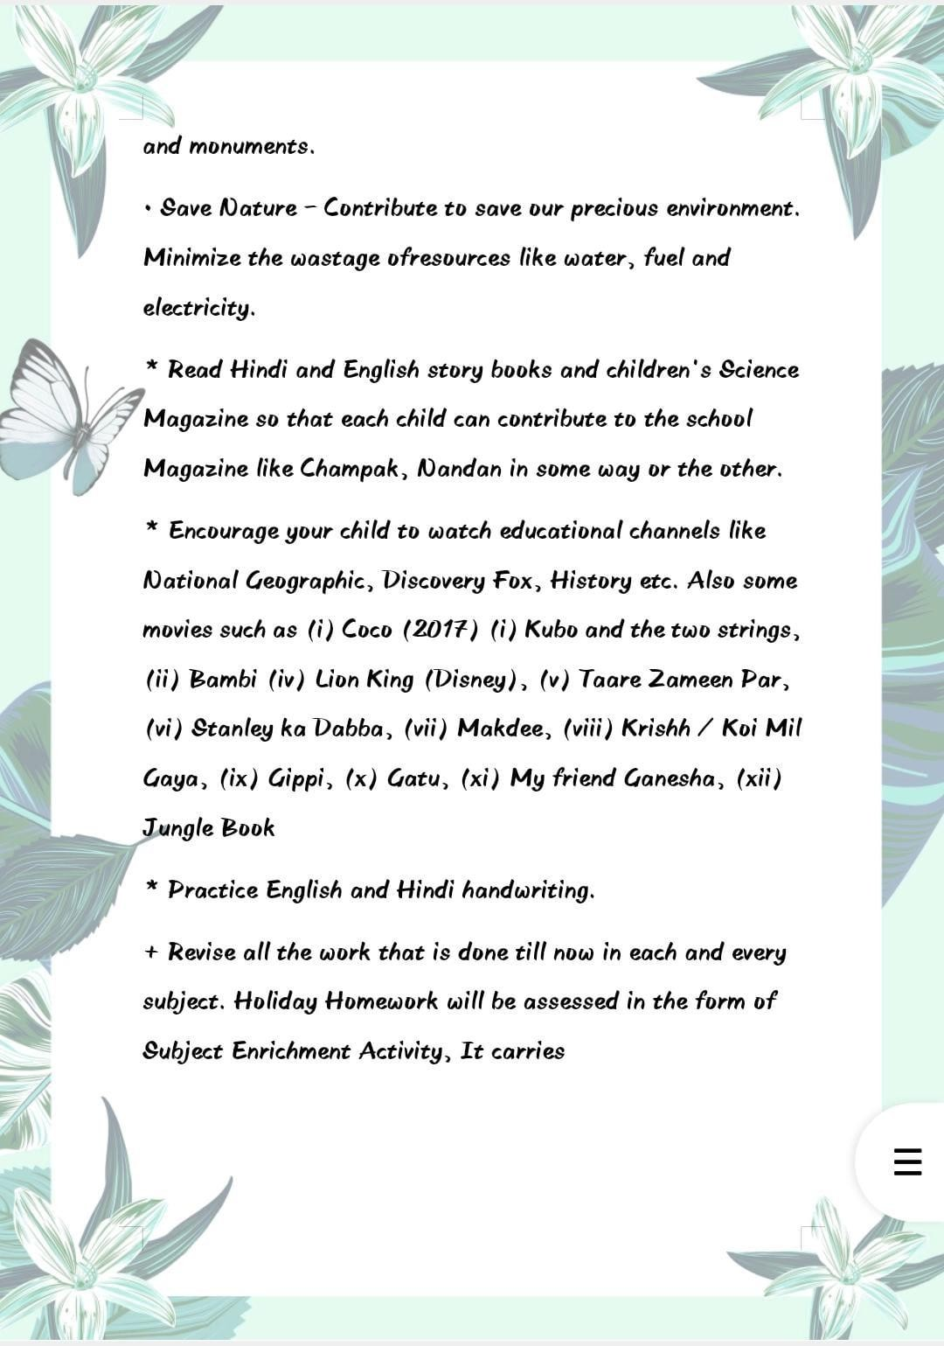

ENGLISH
LITERATURE: Learn and write PA Syllabus in beautiful handwriting in separate notebook.

LANGUAGE:
- Fill book exercise of Ch- 1, 2 and 3 in book.

- These collective nouns are all mixed up. Write them correctly.
- an orchard of chicks
- A litter of soldiers
- A fleet of puppies
- A brood of cars

- Complete these sentences with some, any, somebody, something, anyone or anything.
- I don’t want coffee but I would like milk.
- Is there at home?
- There isn’t in the bag.
- Would you like to eat?
- There is outside who wants to talk to you.
- Has seen my bag?

Q4) Fill in the blanks with suitable pronouns.
- am very hungry. Give something to eat.
- Here are the clothes you gave are all small.Please take back.
- I sold the car because was troubling A lot.

Q5) What changes do we see in joint family in India.

Q6) What types of disputes are common in joint family?

Q7) What loss has the aged face?

Q8) Write the suitable meaning of extreme.

Q9) Give suitable title to the passage.

Q10) These collective nouns are all mixed up. Write them correctly.
- an orchard of chicks
- A litter of soldiers
- A fleet of puppies
- A brood of cars

Q11) Complete these sentences with some, any, somebody, something, anyone or
anything.
- I don’t want coffee but I would like milk.
- Is there at home?
- There isn’t in the bag.
- Would you like to eat?
- There is outside who wants to talk to you.
- Has seen my bag?

Q12) Fill in the blanks with suitable pronouns.
- am very hungry. Give something to eat.
- Here are the clothes you gave. are all small. please take back.
- I sold the car because was troubling A lot.
- Myuncle slipped and hurt leg badly. I had to take to the hospital.

Q13) These collective nouns are all mixed up. Write them correctly.
- an orchard of chicks
- A litter of soldiers
- A fleet of puppies
- A brood of cars

Q14) Complete these sentences with some, any, somebody, something, anyone or
anything.
- I don’t want coffee but I would like milk.
- Is there at home?
- There isn’t in the bag.
- Would you like to eat?
- There is outside who wants to talk to you.

MATHS
- Revise P.A-1 syllabus in rough notebook.

Worksheet -1
- What is the difference of the place value and the face value of 2 in 845260?
- Write the number name in Indian System for:
  - 7714565 b)215122882
- Arrange the following numbers in Ascending Order:
2682995, 44973803, 778646, 51457036,
70925478
- Write the number name in International System for:
  - 15149489 b)23028539
c) 34056223 d)59975882
- The river Mississippi-Missouri has a total drainage area of 2995052 square kilometers. What is this value if you round it off to the nearest ten?
- The number just after the smallest nine-digit number is:

Choose correct answers from given choice

- The number 7068838 in expanded form is represented as:
  - 7068838 b)7000000+60000+8000+800+30+8
c) Seven million sixty-eight thousand eight hundred thirty-eight

- In a given number, if you move some digit one place to the left, then the place values of that digit changes by this factor:
  - 0 b)11
c) 100 d)10

- There are zeroes in ten lakhs.
a) 6
b)5
c) 4
d)7

Worksheet -2
- Arrange the given in ascending order:
  - XXXIV, XIX, XXVI, VIII
  - VI, IV, VIII, VII
  - IX, XII, X, XIII d)XX, XXX, XXIX, XII e) VIII, I, XXI, XVI

- Compare the given and put the correct sign
<,> or =:
  - 16 XXIII
  - XXXV 45
  - XX XIX
d)5 +13 XXI
e) XXXV 7×4

- Write the sum in roman numerals:
a) II + V =
b)IV + VI =
c) X + VII =
d)X + XIV =
e) XX + XIX =

EVS
Chapters Covered:
📗 1. Germination of Plants
💧 2. Water

🌱 Chapter 1: Germination of Plants
Activity 1: Germination Experiment (Hands-On Activity)
- Soak some green gram (moong) seeds overnight.
- Place them on a wet cotton cloth and keep them in a warm place.
- Observe and record their growth over 5 days in a table:
  - Day 1:
  - Day 2:
  - …
- Draw a diagram showing how the seed changes each day.
- Answer: What conditions are needed for germination?

Activity 3: Worksheet Questions
- What are the main parts of a seed?
- What are the three main conditions needed for germination?
- Why is sunlight important for a growing plant?

💧 Chapter 2: Water
Activity 4: Poster Making – "Save Water, Save Life"
  - Make a colourful poster showing ways to save water at home and in school.
  - Use catchy slogans and drawings.
Activity 5: Water Survey at Home
  - Make a list of all the ways your family uses water in one day.
Activity 6: Water Sources and Purification
  - Write a short paragraph on:
    - Sources of water (rivers, lakes, rain, etc.)
    - How water is cleaned before we drink it
  - Draw a simple diagram showing water purification steps (filtration, boiling, etc.)
Learning work: Learn and do written practice of ch-1 and 2 in holiday homework notebook.

📘 Submission Instructions:
  - All work should be done in a science notebook or scrapbook.
  - Use colours, drawings, and neat handwriting.
  - Submit the homework on the first day after holidays.

G.K.
- Section 1: Quiz Time! (Answer in your notebook)
  - Who is the President of India in 2025?
  - Which is the largest desert in the world?
  - What is the national animal of India?
  - Which planet is known as the "Red Planet"?
  - Name the currency used in Japan.
  - What is the capital of Australia?
  - How many players are there in a cricket team?
  - Who invented the electric bulb?
👉Write similarly 30 g.k. questions in holiday homework notebook.

🌍 Section 2: Explore the World Activity 1: My Country, My Pride
    - Make a small project on 5 famous Indian monuments.
    - Include:
      - Name of the monument
      - Location
      - One historical fact
      - Draw or paste pictures Activity 2: Flags of the World
    - Draw and color flags of 5 countries.
    - Write the name of the country below each flag.

🌱 Section 3: Current Affairs Activity: News Reporter Task
    - Choose any 3 news items (from a newspaper or TV) that
happened during your holidays.
    - Write a few lines about:
      - What happene
      - d?
      - Where did it happen?
      - Why is it important? Learning Work:
Learn notebook questions and ch-1 to 15 from book.

Computer

Section 1: Theory Questions (Write in your notebook)
  - What is a computer? List its main parts.
  - What is the difference between hardware and software?
  - Write the names of any 5 input devices and 5 output devices.
  - What is a file and what is a folder?
  - Name any 3 operating systems you know.

Section 2: Computer Fun Facts
Activity: Find and write 10 interesting facts about computers.
Examples:
- Who invented the first computer?
- What is the full form of CPU?

🖼️ Section 3: Creative Activity Option A: Draw a Computer Setup
- Draw and label the following:
  - Monitor
  - CPU
  - Keyboard
  - Mouse
  - Printer

Section 3: Learning Work
Learn ch-1 + short cut keys and full forms.

📘 Submission Instructions:
- Theory and drawings to be done in your Computer Notebook or a Scrapbook.
- Practical work to be shown through printouts or screenshots (if possible).
- Be neat and creative!

